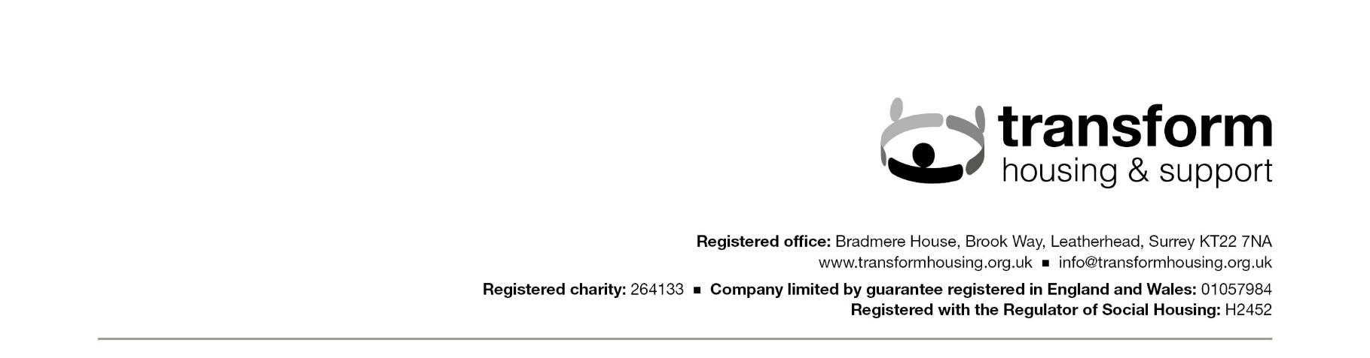
Form: Data Subject Access Request (DSAR) Form

Data Subject Access Requests made to Transform can be made either in person, by telephone, email, letter, social media or in writing in line with GDPR guidelines. Although completion of this form is not a requirement, it would help us gain a clear idea as to the information you require if you could complete and return this form to Transform.

Section A:
Data subject details
Title: | Mr |  |  | Mrs |  |  | Miss |  |  | Ms |  |  |  | Other
First name(s):
Surname: |  |  |  |  |  |  |  | Date request submitted:
Current address:
(if you request the information by post this is the address we will post it to)
Previous address:
(or addresses) if you have moved in the last five years
Telephone number: |  |  |  |  |  | Home number:
Work number: |  |  |  |  |  | Mobile number:
Email address:
Date of birth:
Details of identification provided to confirm name of data subject:
Nature of your connection to Transform: (e.g. current client, ex-client, staff member etc)

Section B:
Details of person requesting the information (if not the data subject)
Are you acting on behalf of the data subject with their written or other legal authority? |  |  |  |  |  |  |  |  | Yes |  |  |  |  | No
If ‘Yes’ please state your relationship with the data subject:
(e.g. parent, legal guardian or solicitor)
Title: | Mr |  |  | Mrs |  |  | Miss |  |  | Ms |  |  |  |  | Other
First name(s):
Surname:
Current address:
Previous address:
(or addresses) if you have moved in the last five years
Telephone number: |  |  |  |  |  | Home number:
Work number: |  |  |  |  |  | Mobile number:
Email address:
Date of birth:
Details of proof that you are legally authorised to obtain this information:

Section C:
The request
Details of data requested (Please be as specific as possible, providing timeframes, names/job titles of people who you believe are processing your personal data and as much information as possible to enable us to locate the personal data that you are requesting):
How would you ideally like the information to be supplied to you?
This could be by post, by email or orally. Please note that, dependent upon volume, we may have to overrule your ideal choice. For example, it would be impractical to convey a large volume of information orally.
Declaration (completed by the data subject)
I, , the undersigned and the person identified as the data subject in Section A of this form, hereby request that Transform Housing & Support provide me with the data about me identified above.
Signature: |  | Date:
Declaration (completed on behalf of the data subject)
I, , the undersigned and the person identified in Section B of this form, hereby request that Transform Housing & Support provide me with the data about the data subject identified above
Signature: |  | Date:
Once completed please either:
- Email the signed and completed form to Transform’s Information Risk Officer at: GDPRinfo@transformhousing.org.uk
- Post the signed and completed form to:
Information Risk Officer, Transform Housing & Support
Bradmere House, Brook Way, Leatherhead, Surrey, KT22 7NA

