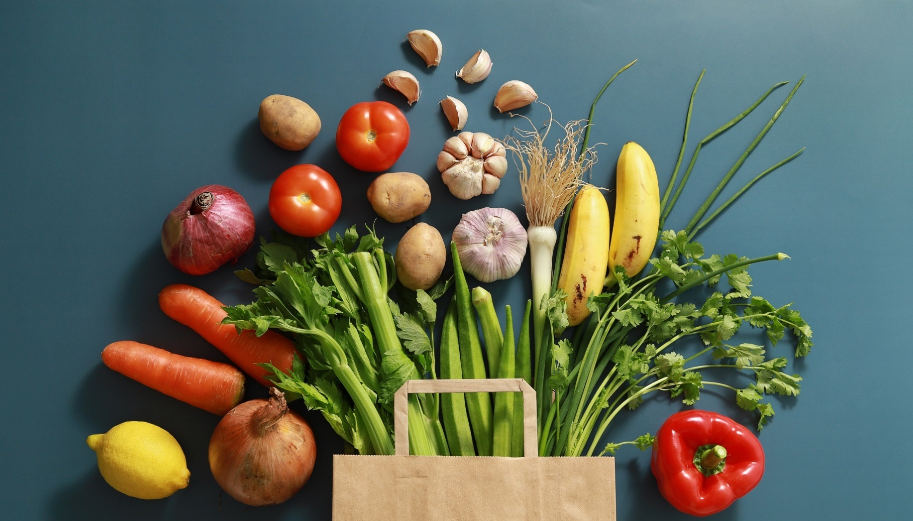


Training module

Eating well and avoiding food waste
In this module you will find guidance on
- planning
- food storage and making the most of your ingredients
- budget friendly and accessible recipes
- how to use the contents of a food back parcel
- links to other agencies for support.

Contents
Section | Description | Page
Introduction | - How does this module work? | 1
Introduction | - Eating well | 2
Introduction | - Food waste | 3
Part A: Eating well for less | - Planning | 4
Part A: Eating well for less | - Food shopping and list making | 4-5
Part A: Eating well for less | - Tips and checklists | 6
Part B: Recipes that work for you | - Budget and lifestyle friendly recipes | 7
Part B: Recipes that work for you | - Cooking without appliances or storage space | 8
Part B: Recipes that work for you | - Cooking with limited mobility and energy | 9
Part C: Making your ingredients last | - Tips on food storage and safety | 10-15
Part D: More resources | - Apps to help avoid food waste | 16
Part D: More resources | - Where to find advice on health, nutrition and other wellbeing resources | 17

Introduction

How does this module work?
Throughout the module you will find various coloured boxes as detailed below:

Remember
 | The purple boxes give you important information which is worth remembering.

Top tips
 | And also top tips for eating well and avoiding food waste.

Action box
 | The blue boxes contain actions for you to complete.

Websites
 | The orange boxes provide links to websites. If you are viewing this training module on a computer or mobile device, then you can just click on the link to be taken to the website. If you are reading this as a printed document, then you can either scan the QR code to the left using the camera on your device or type the website address into a computer or mobile device. www.transformhousing.org.uk

Eating well
Eating well and making healthy choices can feel intimidating. It can seem that other options are more affordable or easy. Some of the things that can stop us from eating well are:
- not knowing where to start
- limited choices or mobility
- not having the storage facilities to buy things in bulk
- not having the time to cook every day
- it can feel like a lot of effort and stress trying to organise meals
- some foods are convenient and easier to find than others
- it can be intimidating.

The points above are valid and it is normal to feel this way.

This guide will show that it is really possible to eat well and make healthy choices, despite this. The key points will be:
- planning
- recipe ideas
- how to store and make the most out of your ingredients
- where to look for help.

Remember
Eating well is about:
- being flexible and still enjoying other things we like in moderation
- doing your best and celebrating when things go well
- learning new skills which might be stressful at first, but will become easier
- looking after ourselves and wanting to feel good
- self-care – we can use meals as daily reminders that we care about ourselves and want to treat ourselves well
- trying to save money, by planning in advance.
It is not about:
- feeling guilty or embarrassed by our choices
- having to follow strict rules and plans everyday
- trying to be perfect – there is no such thing as a perfect approach to eating well and looking after yourself.

This guide does not offer tailored medical or professional support for specific dietary or medical needs. If you have any dietary or medical requirements or think you might need advice on this, please consider the following:
- ask your keyworker for advice on helpful tools and support
- speak to your local GP
- use some of the resources and websites in Part 3.

Food waste
This module will also help you avoid food waste by giving advice on:
- how to store food so it lasts
- when the right time is to get rid of certain foods
- where to donate or share extra food.

Part 1: Eating well for less

Planning
Planning around meals is helpful because it saves time in the long run. However, it can feel intimidating. Adding new habits to your routine might be a challenge because:
- at first it might seem like you are having to do more work by preparing in advance
- it takes time to read, learn and follow this guidance.

These points are valid, but please remember that doing something new always takes a little time to get used to but planning really does help. Planning means:
- feeling less stressed around mealtimes and finances
- knowing what you want to eat and use in advance
- skipping making lots of decisions during the day.

Making good choices around food is about more than nutrition. Food can be a comforting thing and some people enjoy thinking about what to eat or cook. However, it can also be stressful making these decisions and working out the costs. Adding some planning into your routine can allow you to be flexible where you want, but also stop you feeling overwhelmed.

Food shopping and list making
If you get food from a supermarket or online, making lists is very helpful. Please see the Budgeting training module for help around calculating your spending. This guide will look at different ways to use lists to help you make choices.

Making a shopping list
We recommend a few different ways to plan a shopping list, but these are just ideas! Feel free to try some of the suggestions below but remember there is no one right way to shop. If one of the ideas below is helpful, that’s brilliant! But not every plan will suit everyone, it’s about finding the right level of planning for you.

Try thinking about meals and recipes you can enjoy, as inspiration for
your shopping
One helpful way to prepare for a food shop is to decide on a few recipes you would like to make first. That way you can work out roughly how much you will spend, what you will buy and what to cook, before you do your shopping. Please see the recipe section on page 8 for inspiration.
Weekly meal plans
Some people find it helpful to draw up a weekly meal plan using up ingredients you already have and make a shopping list of any missing items.
- E.g. if you have a bag of oats and know you like making porridge for breakfast every day, think about what you’ll want to buy as toppings.
- Or if you have lots of pasta, think about the different vegetables or sauces you’ll want to serve with this.

Try shopping by section
In the book and website Cooking on a Bootstrap, chef Jack Monroe recommends dividing a shopping list into groups:

Protein
Protein is generally one of the more expensive food groups and we often think about meat and chicken when we talk about protein. Cost effective forms of protein include:
  - bags of frozen fish fillets
  - beans, pulses and lentils are easier and cheaper to store than joints of meat, as they can be kept in a cupboard and have a long shelf life
  - jars of fish paste
  - tins of beans and pulses, or the dried variety to soak and cook in advance.
  - tins of sardines.

Fruit and veg
As well as fresh, you can look at the tinned fruit aisle, the baking department for dried fruit and the freezer department.

Store-cupboard
This includes herbs and spices, flavours, and things to generally make simple ingredients a little more exciting and a lot more versatile. There’s no need to get everything at once.

Dairy
A large pot of natural yoghurt has many uses, either as a standalone breakfast with a little tinned fruit mixed in, as the base for a smoothie with some oats, an ingredient in sauce for meat, a curry base, or to toss through pasta with lemon and herbs.

Value-range cheeses and strong cheeses can be a good idea, because the stronger the flavour, the less you need for a lot of flavour

Carbohydrates
Usually, the most cost effective forms of carbohydrates to buy are:
  - a large bag of oats, which last very long have many uses, like porridge, baking and smoothies
  - potatoes
  - store brand pasta
  - white bread is usually cheaper than wholegrain options. It’s a good idea to mix wholegrain and white flours where possible, to get a variety of vitamins and to boost your fibre intake.

Tips and checklist

Top tips

Here are some top tips on making lists and food shopping
Try not to shop or make food lists when you’re hungry
Ask your key worker for help when planning your shopping and budgeting
Stay open minded
If one planning style seems difficult or doesn’t work for you, don’t worry! We all have different learning and planning styles. Keep going and try a different plan instead.
Keep it simple
If you’re keen to try out new recipes, this guide is definitely for you! Just remember to pace yourself and think about the time it can take to cook and learn new things. It’s important to buy the other staple ingredients you know how to use. This is so you have enough ingredients for quick and easy meals you are familiar with, as well as for fun and healthy new discoveries.
Think about quantities, especially when trying new things
Buying in bulk can be cheaper and helpful if you have storage space. It’s also great to try new things and find more ingredients like fruits and vegetables we want to try using. If you haven’t tried something before or in a long time, it’s wise to buy a small amount first and see if you enjoy using it before buying larger quantities next time.
Check the prices each time
Other times, buying fruits or vegetables individually works out cheaper than buying a pack, especially if the pack is prewashed. It’s worth checking each time.
If you have a freezer, look for frozen alternatives to fruit and vegetables
These can be cheaper, last a lot longer, can be quicker to cook with and they don’t always need washing or chopping. Some frozen options, like pre-roasted vegetables, are already cooked and just require defrosting.

It is important to seal and reseal frozen foods carefully and to follow expiration dates.
Try to shop during the happy hour
Most supermarkets discount fresh items towards the end of the day. It’s worth asking a member of staff at your supermarket for fresh food reduction times to see if it’s possible to shop at this time. Please make sure to check the expiry dates on these products as they tend to fall within 24-48 hours.

Part 2: Recipes that work for you

Budget and lifestyle friendly recipes
Variety makes cooking and eating enjoyable, but it can also feel overwhelming. Learning new recipes can be stressful for the following reasons:
- a new recipe might not always turn out as planned – you may be worried about something not tasting great or looking like the picture
- it takes time to learn a new recipe
- lack of choice of ingredients can be frustrating
- lack of kitchen space and limited mobility can make things challenging
- when using different ingredients, you won’t instinctively know how much things will cost.

Recipe-sharing websites
We have chosen the following recipe-sharing websites to try and make things easier, by addressing the above concerns.
 | Cooking on a Bootstrap, by Jack Monroe  This website lists the price of each ingredient and serving. It also includes substitutions and ideas for if you can’t find all the ingredients.  cookingonabootstrap.com/tag/easy-recipes
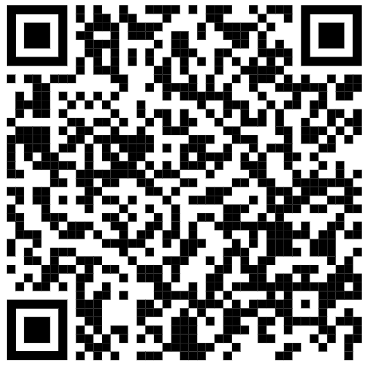 | Family Foodbank cookbook  This free, online cookbook has been created by different organisations. The ingredients are all staples which are often distributed through foodbanks. There are useful top tips to give you alternatives, ideas on what to do with leftovers and cooking on a budget as an individual or for the whole family.  There are also useful pages covering store cupboard ingredients, basic kitchen utensils, basic kitchen safety and basic food hygiene.  www.familyfoodbank.org/uploads/7/9/9/6/79964306/food-bank-recipe-book-final-web-and-email.pdf
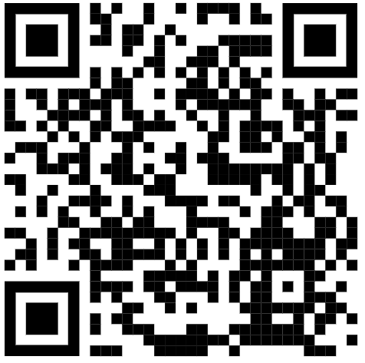 | Cooking in a wheelchair  These accessible cooking videos show simple, low-energy recipes that require minimal chopping.  youtube.com/@KatiePennick
 | Using up leftovers and avoiding food waste  These recipes and videos by Tesco focus on left over ingredients like milk, egg, bread, bananas and tinned foods.  realfood.tesco.com/reduce-food-waste.html

Cooking without appliances or storage space
When we think of cooking we sometimes imagine kitchens full of fancy equipment, gadgets and lots of storage space. This can be intimidating and off putting. On top of that, many recipes assume people will have easy access to ovens, hobs, microwaves and multiple pots and pans. Looking at these recipes can put you off learning a new skill, when just thinking about the logistics is stressful.

Cooking for different types of kitchens and appliances
Whatever the size of your cooking and storage spaces, you deserve nutritious and delicious food. We’ve found some websites which offer simple recipes that cater to different kitchens and that will hopefully result in some tasty meals.
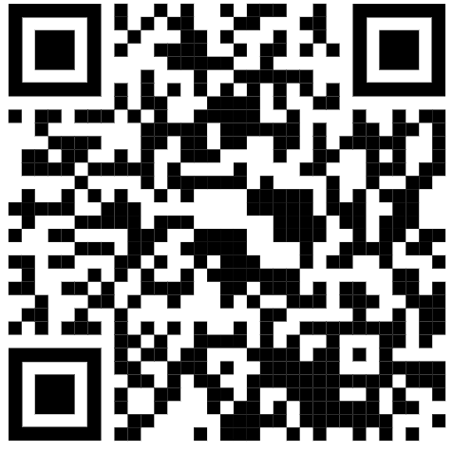 | Microwave cooking  This BBC resource gives recipes for dinners and desserts which can all be made in a microwave, with a focus on budget friendly ingredients.  www.bbcgoodfood.com/howto/guide/what-cook-without-cooker
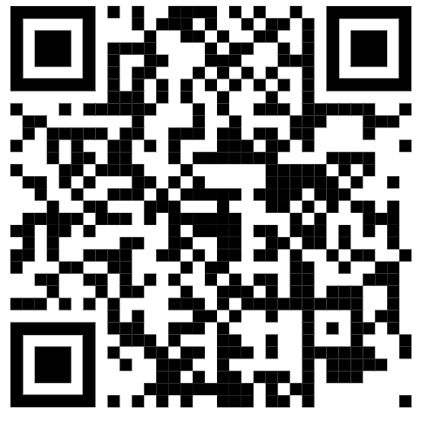 | More main meals that don’t need an oven or a hob  A lot of these recipes rely on using a microwave as a surprising alternative to an oven or a hob. They also require minimal washing up. Some of these recipes suggest using a slow cooker if you have one.  blog.cheapism.com/no-oven-recipes-16744/#slide=11
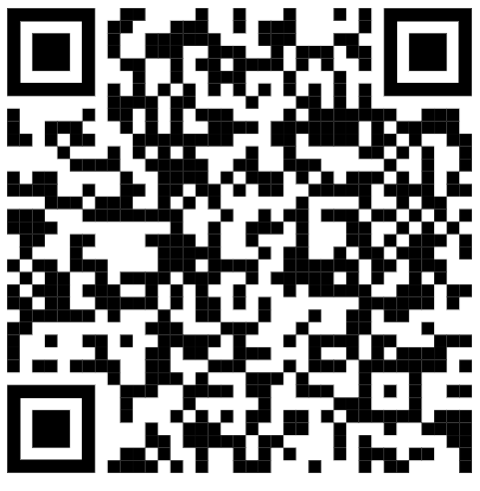 | One pot recipes  These meals can all be made in one pot or pan and use readily available and budget friendly ingredients.  www.eatingwell.com/gallery/7820696/budget-friendly-one-pot-dinner-recipes

Cooking with limited mobility and energy

Tops tips

Tips for cooking with limited mobility or energy
Sharp knives are great for conserving energy
Ask your keyworker for help in using a steel sharpener that can keep a good edge on them.
Try to keep the things you use a lot within reach so you can get to them easily
Replace glass bowls with plastic ones that weigh a lot less
The same applies for mugs, plates and glasses.
Enjoy the process and pace yourself while cooking
When possible, work for a few minutes and then rest for a few minutes. When doing tasks that require you to stay in the same position, like mixing or chopping, sit down when you can.
Ingredient swap
Instead of crushing or finely grating garlic, you can use 1 teaspoon of garlic paste per 1 garlic clove. Another option is garlic powder.
You may find a slow cooker helpful
Lay out everything you will need before you start cooking, to avoid multiple trips to
the fridge

The tips above have been adapted from the following sources:

Links
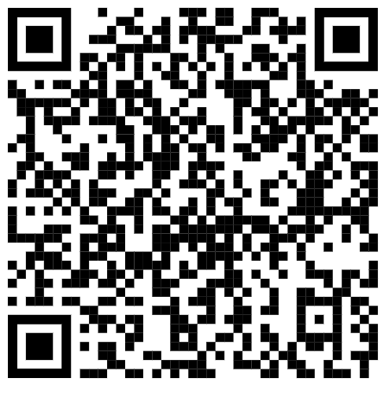 | Cook as you are by Ruby Tandoh – free preview  serpentstail.com/wp-content/uploads/wpallimport/files/PDFs/9781788167529_preview.pdf
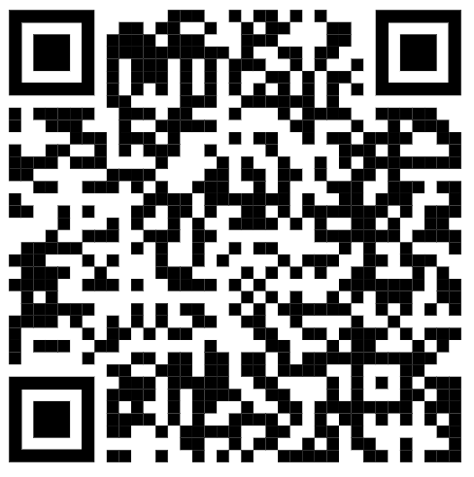 | Eating right with arthritis and limited mobility  www.webmd.com/arthritis/features/eating-right-with-limited-mobility
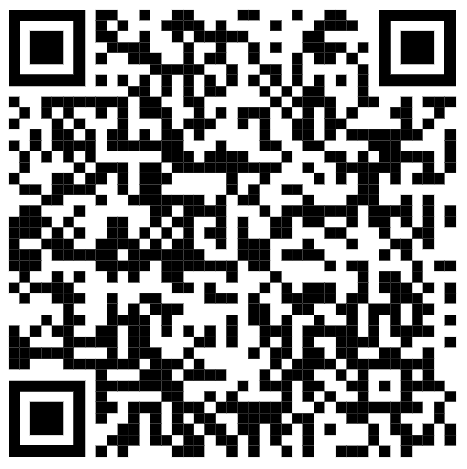 | Cooking with Fibromyalgia and chronic fatigue syndrome  www.verywellhealth.com/cooking-with-fibromyalgia-and-chronic-fatigue-syndrome-4139779

Part 3: Making your ingredients last

Tips on food storage and safety

Guidance
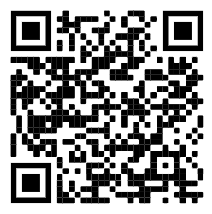 | The Food Standards Agency  The following guidance is adapted from the Food Standards Agency website. It contains a lot of helpful information on food storage and budget friendly recipes.  www.food.gov.uk/consumer-advice/food-safety-advice

Top tips

Here are some top tips on fridge-freezers and on storing food and leftovers
Fridge maintenance
- Keep your fridge temperature at 5°C or below.
- If your fridge has a digital temperature display you may wish to check it against an internal fridge thermometer now and again to make sure it's accurate.
- Clean and inspect your fridge regularly to ensure it remains hygienic and in good working order.
"Use by" dates
- No food lasts forever, however well it is stored. Most pre-packed foods carry either a "use by" or a "best before" date.
- "Use by" dates appear on foods that go off quite quickly. It can be dangerous to eat foods past this date.
- "Best before" dates are for foods with a longer life. They show how long the food will be at its best.
- Food can look and smell fine even after its "use by" date but that does not mean it's safe to eat. It could still contain bugs that could make you ill.
- Eating food past its "best before" date is not dangerous, but the food may not be good quality.

Freezing food
You can freeze many things, including:
- baked goods
- bananas: peel and wrap them or place in an airtight container before freezing
- bread
- cheese (except soft cheese as the freezing process affects the texture)
- eggs, including boiled eggs
- fish
- meat
- milk
- rice: please read rice safety tips on page 14
- yoghurt.

Anything with a high water content like strawberries and tomatoes will go squishy but are still fine to cook with.

Place food in an airtight container or wrap it tightly in freezer bags or similar before placing in the freezer otherwise the cold air will dry it out.
What goes in a fridge?
- Some foods need to be kept in the fridge to help slow down germs' growth and keep food fresh and safe for longer.
- These are foods marked with a "use by" date and "keep refrigerated" on the label, such as milk, meat and ready meals.
- Cool down leftovers as quickly as possible (within two hours), store them in the fridge and eat them within two days.
- Avoid putting open tin cans in the fridge, as the food inside may develop a metallic taste.
- Follow the manufacturer's instructions or place the contents in a storage container or covered bowl before refrigerating.

Storing specific foods
Storing meat and poultry
It's important to store meat safely in the fridge to stop bacteria from spreading and avoid food poisoning.
- Store raw meat and poultry in clean, sealed containers on the bottom shelf of the fridge.
- Follow any storage instructions on the label and do not eat meat after its use by date.
- Keep cooked meat separate from raw meat and ready-to-eat foods in general.
Storing eggs
Eggs are best stored in the fridge as they are kept at a constant temperature. Eggs can also be frozen. There are two ways to freeze eggs:
- crack the egg and separate yolks and whites into separate plastic containers or food bags before freezing. This is handy for baking
- crack the egg into a plastic tub and beat it before freezing – great for omelettes and scrambled eggs

You can safely store a boiled egg in the fridge for a couple of days. Boiled eggs can also be frozen.
Freezing and defrosting meat and fish
It's safe to freeze meat and fish as long as you:
- cook food until it's steaming hot throughout
- defrost meat and fish thoroughly before cooking – lots of liquid will come out as meat thaws, so stand it in a bowl to stop bacteria in the liquid spreading to other things
- defrost meat or fish in a microwave if you intend to cook it straight away or, if not, defrost in the fridge overnight so it doesn't get too warm
- freeze it any time before its use by date.

Other things to remember:
- Date and label meat in the freezer and eat it within 24 hours of defrosting.
- Make sure meat is properly wrapped in the freezer or it might get freezer burn which can make it tough and inedible.
- You can freeze meat for a long time and it will still be safe to eat, but the quality will deteriorate so it's best to eat it within three to six months. Do not worry if it's frozen for longer – try marinating it before cooking to improve texture or use herbs and spices to add flavour.

Refreezing meat and fish
- Frozen raw foods can be defrosted once and stored in the fridge for up to 24 hours before they need to be cooked or thrown away.
- Never refreeze raw meat (including poultry) or fish that has been defrosted.
- To reduce wastage, divide the meal into portions before freezing and then just defrost what you need.
- You can cook frozen meat and fish once defrosted and then refreeze it.
- You can refreeze cooked meat and fish once, as long as they have been cooled before going into the freezer. If in doubt, do not refreeze.
How to make the most out of frozen leftovers
- Cool leftovers as quickly as possible, ideally within two hours.
- Divide leftovers into individual portions and refrigerate or freeze.
- Use refrigerated leftovers within two days.
- When reheating food, make sure it is heated until it reaches a temperature of 70°c for two minutes, so that it is steaming hot throughout.
- Always defrost leftovers completely, either in the fridge or in the microwave.
- When defrosted, food should be reheated only once, because the more times you cool and reheat food, the higher the risk of food poisoning.
- Cooked food that has been frozen and removed from the freezer should be reheated and eaten within 24 hours of fully defrosting.
- Foods stored in the freezer, such as ice cream and frozen desserts, should not be returned to the freezer once they have thawed.
- For safety and to reduce waste, only take out of the freezer what you intend to use within the next 24 hours.
Tips on serving rice safely
- Do not reheat rice more than once.
- Ideally, serve rice as soon as it has been cooked.
- If that is not possible, cool the rice as quickly as possible (ideally within one hour).
- Keep rice in the fridge for no more than one day until reheating.
- When you reheat rice, always check that it's steaming hot all the way through.

Bakery advice
Sliced bread, pitta, crumpets, hot cross buns and bagels can all be frozen and can be toasted straight from the freezer.

Leftover bread crusts and slightly stale bread can be turned into breadcrumbs when whizzed in the food processor. These can be stored in the freezer for use in bread sauces, savoury crumbles or coating chicken or fish.

If you’d rather not use bread for sandwiches because it’s starting to go hard, it can still make great toast.

You can freeze leftover cake in slices. Cake can be frozen for up to one month without affecting the taste or texture if wrapped in a layer of cling film followed by a layer of foil.

Bread goes stale much faster in the fridge. Instead, store in a cool, dark and dry place such as a bread bin or store cupboard. Remember to re-seal the pack.

A day old loaf of bread can be freshened up by being sprinkled with water and put in a hot oven for 10 minutes. It will be soft and crusty like a new loaf.

Spread garlic butter on the crusts from a loaf and toast under the grill. Cut into fingers and serve for a quick and easy snack.

Part 4: More resources

Apps to help avoid food waste
This is where technology can help. There are some great apps you can use that will help with shopping for and planning your meals. This means you only buy what you need and you use everything you bought! Others allow you to buy local food that would otherwise go to waste, for example from restaurants in your area.
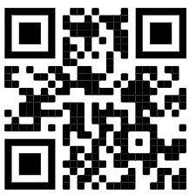 | No waste  This food app has tools that help you to reduce food waste, over-buying and wasted money. Features include a barcode scanner, ‘use by/best before’ date reminders and a meal-planning feature.  www.nowasteapp.com
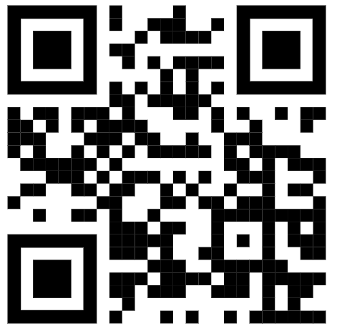 | Kitchen  Save food and money with this free app that designs recipe plans after scanning your grocery shopping receipts. It helps you keep track of the food you have at home even when you’re on the move, reducing the amount of food and money otherwise wasted each week.  kitche.co
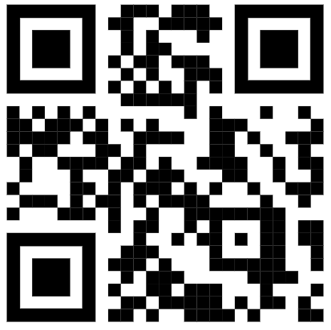 | Olio  This app has been designed to link-up surplus food with neighbours and local retailers to avoid food going to waste. You can also trade other items such as garden tools or kitchen appliances.  olioex.com
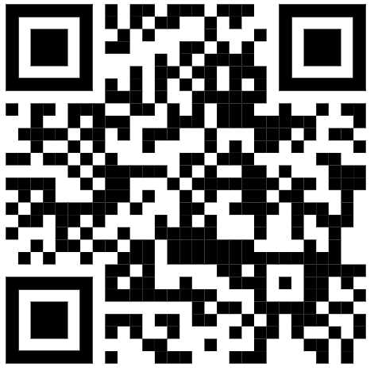 | Too Good To Go  This app offers you the chance to get a ‘green’ takeaway! Buy surplus food from shops at a reduced price, meaning you get to tackle food waste in a delicious way.  toogoodtogo.co.uk

Where to find advice on health, nutrition and other wellbeing resources
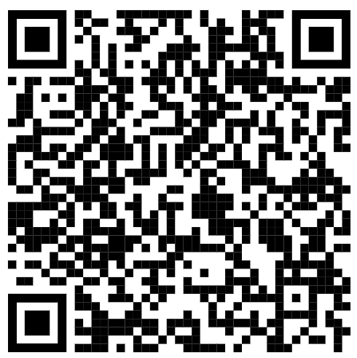 | NHS guide for healthy eating  These eight practical tips cover the basics of healthy eating and can help you make healthier choices.  www.nhs.uk/live-well/eat-well/how-to-eat-a-balanced-diet/eight-tips-for-healthy-eating
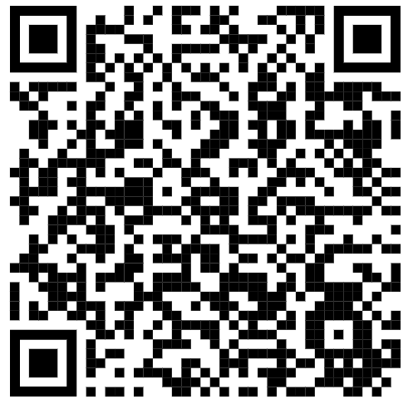 | Mind – food and mood  Explores the relationship between what you eat and how you feel, including tips on how to incorporate healthy eating into your life.  www.mind.org.uk/information-support/tips-for-everyday-living/food-and-mood/healthy-eating-tips

