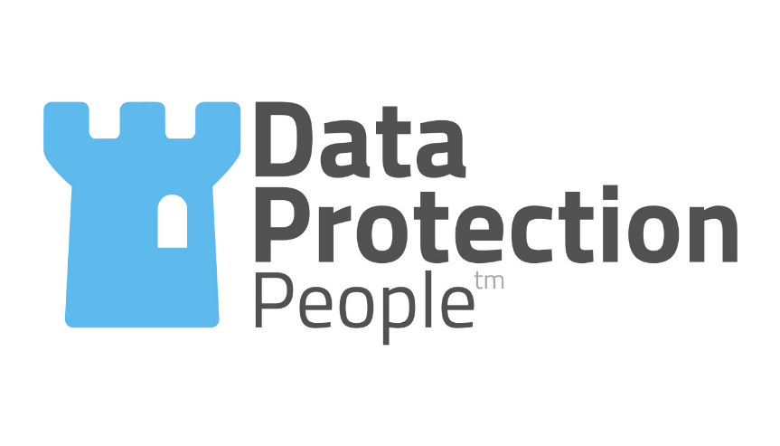


DATA PROTECTION MADE EASY

STANDARD SUPPLIER QUESTIONNAIRE

Background
Data protection law requires data controllers to use only data processors who can provide sufficient guarantees to implement appropriate technical and organisational measures in such a manner that processing will meet the requirements of the data protection legislation and also to ensure the protection of the rights of individuals. Data processors are not permitted to engage another processor without prior specific or general written authorisation of the data controller thereby giving the data controller the opportunity to object to the use of any such sub-processors.
Processing by a data processor must be governed by a contract that is binding on the data processor and which is required by law to contain certain information and terms.

Purpose
The purpose of this supplier questionnaire is to allow the instructing organisation to evaluate the arrangements for data protection compliance management and information security at the supplier and hence the risk to its data processing activities and the instructing organisation’s compliance.

Instructions
You are requested to complete this questionnaire truthfully and completely to facilitate this evaluation. Please provide copies of policies, procedures and other documentation so that your internal arrangements can be assessed.

Disclaimer
The information disclosed shall be used only for the purposes set out above. An opinion will be formed as to your likely risk to the instructing organisation based on the information you do or do not provide. Any assessment shall be based on the information provided by you and shall represent an opinion with regard to likely compliance and likely risk. The instructing organisation and its agents and representatives accept no responsibility nor any liability for any damage or loss howsoever caused as a result of your completion, partial completion or failure to complete this supplier questionnaire and/or to engage in the supplier evaluation process.

Section One – Contact Information

Q1 Please provide the information requested in the table below.
Name of organisation submitting this questionnaire.
Contact details of person submitting.
Date of submission.

Section Two – Relationship

Q2 Describe the relationship you believe you have with the issuing organisation and the services you provide to them.
Describe the nature of the relationship with the issuing organisation.
Describe the services your organisation is providing to the company?

Section Three – The data being processed

Q3 Describe the data processing operations/activities you undertake on behalf of the issuing organisation.

Q4 Describe the types of information that you are processing on behalf of the issuing organisation.

Q5 What is the purpose of the data processing activities/services that you provide to the issuing organisation?

Section Four – Data Flows and Information Security
Q6 How do you obtain or receive the information above?

Q7 Where (i.e. the geographic location(s)) do you undertake the actual processing and/or storage of the personal data you process on behalf of the company. List all locations including file/web servers, back-ups, mirrored servers, hosting platforms etc.

Q8 Do you hold any certifications or accreditations relating to information security and/or quality management e.g. Cyber Essentials, ISO27001 etc. Please provide copies of any relevant certificates, attestations of compliance and statements of applicability.
Certification | Cert Number | Renewal Date | Awarding Body | Scope of Certification

Q9 Describe the measures you have implemented to protect against the accidental or unlawful destruction, loss, alteration, unauthorised disclosure of, or access to personal data you are processing for the issuing organisation. Please provide copies of any policies procedures, work instructions and registers/logs.
For example, Anti-Virus, Malware, Anti-Spyware, Intrusion Detection, Firewalls, Vulnerability Scans of Workstations and Servers, Independent Penetration Testing of Network and Internet Facing Applications, Physical Security Measures, Role Based Access Controls, Systems Monitoring.

Q10 Describe the measures you have implemented:
- To ensure the ongoing confidentiality, integrity, availability and resilience of processing systems and services?
- To restore the availability and access to personal data in the event of a physical or technical incident?
Please provide copies of any policies procedures, work instructions and registers/logs.

Q11 Do you have a program of undertaking vulnerability scans and penetration testing on the data systems, people and processes that are involved in processing data on behalf of the issuing organisation?
Yes/No*
Please provide further details
Date | Type of scan/test | Who did the scan | Scope of scan/test

Section Five – Use of Artificial Intelligence

Q12 Will any of the processing involve the use of AI?
If you have answered “No” to Q12, proceed to section six
Q13 Is the software supplier or service provider the owner and controller of the AI model being used? Please explain your answer.
Q14 Will information provided to or by the AI model be available to the supplier and/or the model owner or developer if that is not the supplier? Please explain your answer.
Q15 Will information provided to or by the AI model be used to improve the model? Please explain your answer.

Q16 How is the accuracy of the AI model defined and tested?
Q17 Please explain what measures are in place to test for and mitigate bias in the data used to develop and train the model and in the model outputs. Please be specific about particular demographics for which bias is tested.
Q18 How does the solution provide for human intervention in the event of something going wrong?

Section Six - Sub-contractors

Q19 If you use any other organisations to process information on behalf of the company please provide a list and indicate what they do for you and their location. Include cloud hosting providers, data centres, freelance developers etc.
Organisation Name | Service Provided | Location
Example | Data Centre | Germany

Q20 Do you have a documented process for selecting and appointing other organisations that process or handle the information? Please provide copies of any policies procedures, work instructions, checklists, and registers/logs.

Q21 What due diligence do you undertake on suppliers of services that affect the personal data of the issuing organisation? Please provide copies of any policies procedures, work instructions and checklists.

Section Seven - Personal data breaches and security incidents
Please provide copies of any policies procedures, work instructions, checklists, and registers/logs

Q22 Please detail the arrangements you have in place for recognising and handling security incidents and personal data breaches.

Q23 Explain the arrangements you have in place for notifying relevant people about security incidents and personal data breaches including the organisation you are processing on behalf of.

Q24 What obligations are your data processors and other supplies under to inform you of security incidents and personal data breaches?

Section Eight – Handling Information Rights
Please provide copies of any policies procedures, work instructions, checklists, and registers/logs

Q25 What measures do you have in place to recognise and handle requests from data subjects to exercise their rights set out in data protection law (e.g. subject access requests, erasure, correction and portability requests, and objections to processing etc. in particular, in your capacity as a data processor.

Section Nine - Employee management
Please provide copies of any policies procedures, work instructions, checklists, and registers/logs

Q26 What measures do you have in place for pre-employment screening of personnel that are able to access personal data you are processing on behalf of the issuing organisation?

Q27 Who is trained, how and on what topics? What triggers the need for employees to undertake training (e.g. induction, annual refresher training etc.)?

Q28 How do you ensure that your employees and others who have access to the data being processed on behalf of the issuing organisation are committed to confidentiality?

Section Ten - About Your Organisation

Q29 Has your organisation registered with the Information Commissioner’s Office?
- Yes – Please quote your Registration Number below
- No
- Don’t Know
- No as we are Exempt (explain why you are exempt below)
We believe we are exempt from registering with the ICO because:

ICO Reg. Number | Payment Tier | Expiry Date

Q30 Do you have a designated individual who is responsible and accountable for data protection compliance, information governance?
Role | Name | Job Title | % of time spent on data protection
Data Protection Compliance
Information Governance
Information Security

Q31 Do you have any of the following documents:
Document purpose | Yes/No | Document Name | Current version
Policy on data protection compliance management
Information Security Management Policy
Records of processing activities (as envisaged by Article 30 GDPR)
information Security Incident Management and Personal Data Breach Reporting Procedure
Business Continuity/Disaster Recovery Plan
Procedure for Managing Data Sharing and Disclosures
Policy on the acceptable use of IT equipment and data
Please provide copies of any policies procedures, work instructions.

Section Eleve – Compliance checking
Please provide copies of any policies procedures, work instructions, checklists, and registers/logs.

Q32 Describe the measures you have implemented for regularly testing, assessing and evaluating the effectiveness of technical and organisational measures you have implemented to ensure the security of data processing operations, systems and services.

Q33 When did your organisation last undertake a data protection compliance audit? What was its scope?

Q34 How frequently do you undertake data protection compliance audits?
- Never
- No pattern
- Once every two years
- Annual
- Monthly
Please provide a copy of the audit plan for the last 12 months and next 12 months

Section Twelve - Disposal and decommissioning
Please provide copies of any policies procedures, work instructions, checklists, and registers/logs.

Q35 What is your organisation’s process for disposing of personal data when it is no longer required?

Section Thirteen – Declaration

Date completed
Completed by
Position
Thank you for completing the due-diligence questionnaire, it will help us to fulfil our data protection obligations. The information you provide will be used in accordance with our Privacy Policy and for the purposes of assessing the data processing risk presented by your organisation. We may share your response with our professional advisors, Data Protection People Limited which is subject to a non-disclosure and confidentiality agreement with us and with any up-stream processors or controllers as required to demonstrate compliance with the GDPR. We will retain this questionnaire for as long as we need to for the purposes of demonstrating compliance with the GDPR.

