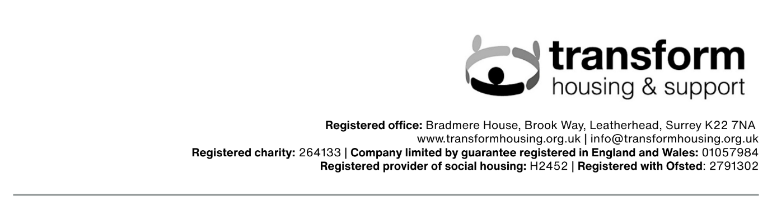

New Supplier On-boarding Form

Instructions for Completion

Please complete all parts of the form.

Contractors/suppliers should answer all questions as accurately and concisely as possible. Where a question is not relevant to your organisation, please indicate “Not Applicable” and briefly explain why.

Supporting information should be presented in the same order as, and should be referenced to, the relevant question.

Response form

Please complete all of the following sections:

- Company and Legal Due Diligence

Full Name & Address
Email Address
Telephone Number
Public or Private Company

Company Registration Number | Number:  Year Registered:
VAT Registration Number

Address of Registered Office (If different)

What services/goods do you provide?

Have you completed, or are you currently working on, any projects with Transform Housing & Support?
How many direct employees do you have?

Please confirm the hours/days you work, for example, 24 hours per day, 7 days per week.

Please confirm whether these hours are acceptable to your workforce and sub-contractors and that you have covenants in place to comply with the Working Time Regulations.

Do you normally sub-contract any trade or service?  If yes, are you registered with the CIS scheme?  Please provide brief details as to what is sub-contracted and who to: | Yes/No  UTR No: ____________________________________
If you are completing this questionnaire as a subsidiary company, please provide full name and address of parent or holding company.

- Financial and Risk Assessment

Please attach a copy of your policy statements for the following, where there is none, please state ‘no policy’ next to the item.

- Risk Management

- Equality & Diversity

- GDPR

- Environmental Responsibility

- Sustainability & Resource Use

- Business continuity Plan

Have you had any other CCJs over the past 5 years?

Are there any outstanding legal actions or investigations?

Have any Prohibition, Improvement or other Enforcement notice(s) been issued against your company within the last five years?

How do you confirm employees’ and subcontractors’ legal right to work in the UK?

- Health & Safety Assessment
Please attach your health & safety policy (if you do not have one, you will be expected to comply with Transform Housing & Support's policy.)

Who in your organisation has overall responsibility for Health & Safety?
- Name
- Job Title
- Contact Details (email, contact number)

How do you:  - Obtain Competent H&S advice? - Internal staff member / external consultant  Please provide contact details: name, address, email, contact number.  Please provide details and evidence of competence/qualifications | ☐ Internal member ☐ External consultant
Do you hold CHAS Accreditation, SSIP or equivalent, if so, please supply the certificate.  SSIP name:  Expiry date:  Certificate attached | ☐ Yes ☐ No
What Health & Safety training has your organisation completed in the past 3 years?
Who attended?

Include training matrix/records where available.

Please state how you ensure your sub-contractors have a sufficient health & safety policy.
- Evidence of qualifications, training, insurance checks, etc.

Please provide accident/incident statistics for the last 12 months:  - Total number of incidents.  - Number of RIDDOR reportable incidents.  - Example of one incident and remedial action taken | ☐ Yes ☐ No
Have you received any enforcement notices, prosecutions, or legal actions under health, safety, or fire legislation in the last 5 years (including pending cases)?  - If yes, please provide details and remedial actions taken | ☐ Yes ☐ No
How do you communicate H&S information to your workforce?

- Inductions, toolbox talks, staff meetings, newsletters, noticeboards, forums/committees, etc

- Frequency of communication (daily, weekly, monthly, etc.)

How do you monitor, audit, and review your H&S performance and procedures?

Please provide an example of a completed risk assessment relevant to your works, showing hazards identified and control measures.

If your works may involve the following, please provide evidence of policies/procedures and recent training records (where applicable):

- COSHH (hazardous substances) – COSHH policy and example assessment.

- Working at Height – procedures and training records (within last 3 years)

- Lone Working – procedures for managing lone working risks.

- Asbestos – policies and training, and if licensed/non-licensed, provide HSE licence or disposal procedures.

- Gas & Electrical Work – certificates of competence

- Compliance, Data Protection and Safeguarding

Is your company registered with the Information Commissioner’s Office (ICO) under the Data Protection Act 2018 / UK GDPR?  We undertake Data Protection Due Diligence on all contractors working with us. Please can you complete our Due Diligence Questionnaire. This is available on our website here (insert link to page when available? | ☐ Yes ☐ No
Do you have a Safeguarding Policy? | ☐ Yes ☐ No (Attach if yes)
Have relevant  staff/subcontractors completed safeguarding training and how frequently is this training refreshed? | ☐ Yes ☐ No
Do you have a policy in place to ensure all staff working with vulnerable adults hold a DBS certificate at all times and how frequently is this renewed? | ☐ Yes ☐ No
Do you have a Modern Slavery Statement (if applicable)? and if so, please provide a link to where it is published on your website? | ☐ Yes ☐ No
Are you compliant with ethical conduct codes? | ☐ Yes ☐ No
Do you conduct background checks on staff and subcontractors? If in contact with our clients, please provide a copy of your recruitment and selection policy and confirm that you follow safer recruitment practices. | ☐ Yes ☐ No
Please disclose any Conflicts of Interest:

For example, if anyone in your organisation is related to a tenant, Trustee, or staff member of Transform Housing & Support.

- Insurance Details

Insurance Type | Insurer | Policy number | Coverage Amount | Business Activity Covered | Renewal Date | Copy Attached ✔/✘
Employers Liability

Professional Indemnity

Public Liability

Other (specify if applicable)

Additional requirements
Please confirm the following and provide supporting evidence when requested:
- Our Public Liability policy covers accidental damage caused during works, including cleaning, repairs, maintenance, and alterations ☐
- Our policy covers damage to neighbouring properties caused by our works ☐
- Where works involve demolition, erection, or structural alterations, we confirm we hold adequate insurance to cover these activities (note: Transform’s policy does not cover this) ☐
- We confirm that our insurance provides cover of not less than £5 million Public Liability and £10 million Employers’ Liability (or as otherwise agreed) ☐
- We confirm we will provide completion certificates or industry-standard certification for works undertaken, where applicable ☐
- We confirm our staff and subcontractors are appropriately qualified and accredited, and we can provide evidence of training/competence on request ☐

- Have you included all required documentation with this form?

- ☐Policies
- ☐Insurance Certificates
- ☐Safeguarding Policy
- ☐SLA
- ☐Other

- Declaration to be signed by a Director, Partner, or Business Owner

The answers given to the above questions are a true reflection of this company’s operations, policy, and safety record. Furthermore, we confirm that all premiums have been paid to date and the above stated insurance policies are not subject to any express conditions which would affect cover for work which would be undertaken for Transform Housing & Support

Signature:

Print Name:

Position Held:

- FOR INTERNAL USE ONLY – Finance Sign-Off

Supplier Onboarding Checklist | Completed | Date | Initials | Finance comments | Outcome, Action Required
Bank Details Verification Form | ☐ |  |  |  | If details are incorrect, escalate to Finance for review before proceeding.
Barclays Bank Verification | ☐ |  |  |  | If verification fails, hold onboarding and notify Finance immediately.
Dun & Bradstreet Check | ☐ |  |  |  | If negative report, escalate to Finance Director for review/approval before onboarding.
All documentation received and verified. | ☐ |  |  |  | Ensure all required documents are complete, if any missing follow up with supplier before onboarding
SLA | ☐ |  |  |  | Please provide a link to the relevant entry in the contracts register.

Reviewed and approved by:

Senior Finance Officer

Director of Finance

Chief Executive (if above delegated threshold)

Date

Approved in accordance with Transform Housing & Support's internal policies and delegated authorisation limits.

